Timothy Leishman Word Count: 00,000

Pocatello, Idaho, 83202

[leistimo@isu.edu](mailto:leistimo@isu.edu)

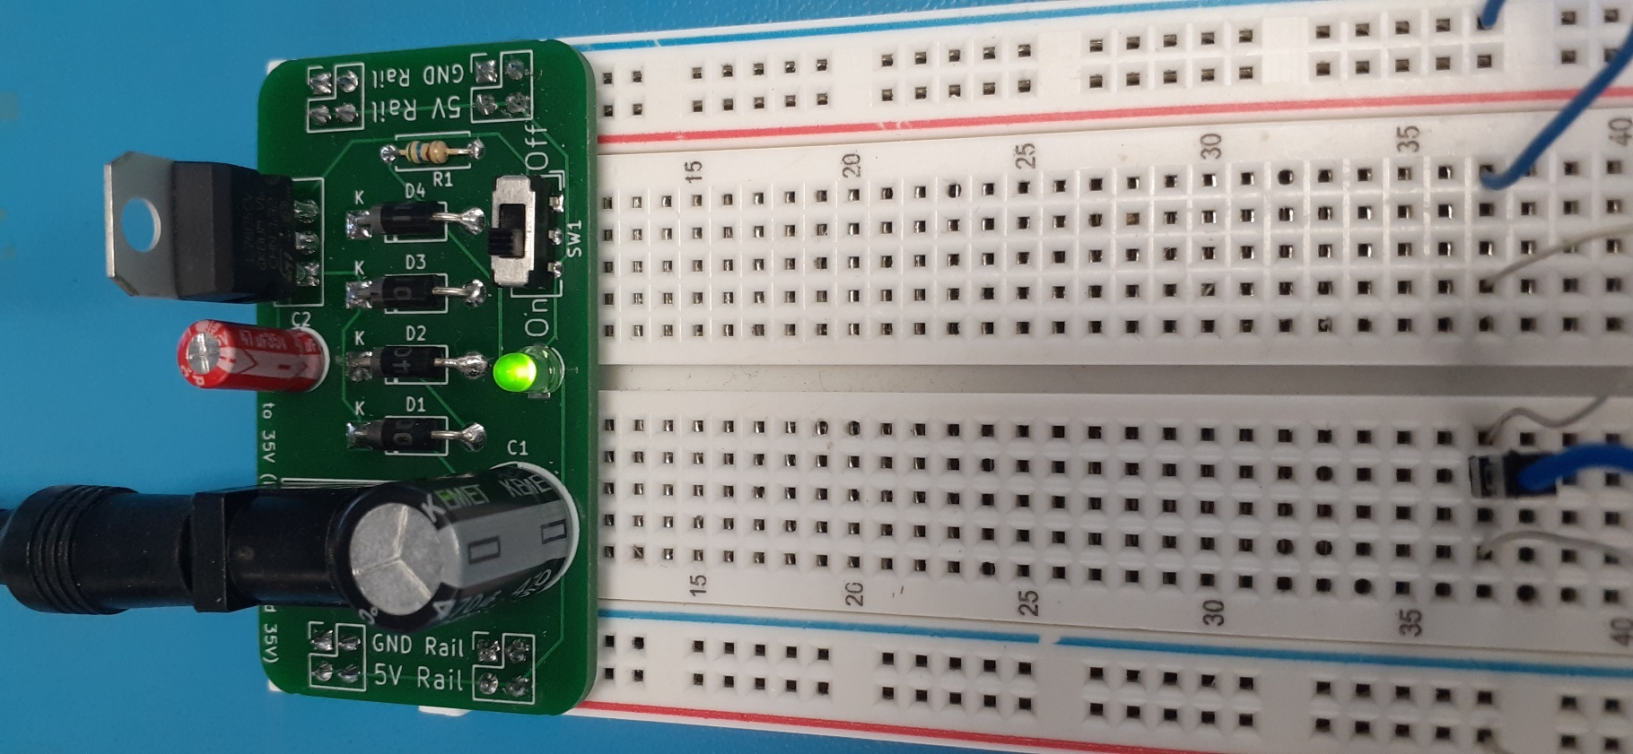

**Breadboard Power Supply**

**Timothy Leishman**

*Senior Instructor, Robotics Engineering Technology*

*Idaho State University*

**Contents**

* Section 1 Introduction 2
* Section 2 RMS & Peak Voltage 4
* Section 3 Voltage Rectification 5
* Section 4 Capacitive Filtering & DC Calculations 7
* Section 5 Voltage Regulation 9
* Section 6 Your First Power Supply Project 13
* Section 7 Zener Regulation 16
* Section 8 Input Polarity Correction 20
* Section 9 Basic Current Limiting Protection 21
* Section 10 The Darlington Pair 24
* Section 11 The L7805 Regulator 26
* Section 12 Breadboard Power Supply Assembly 29

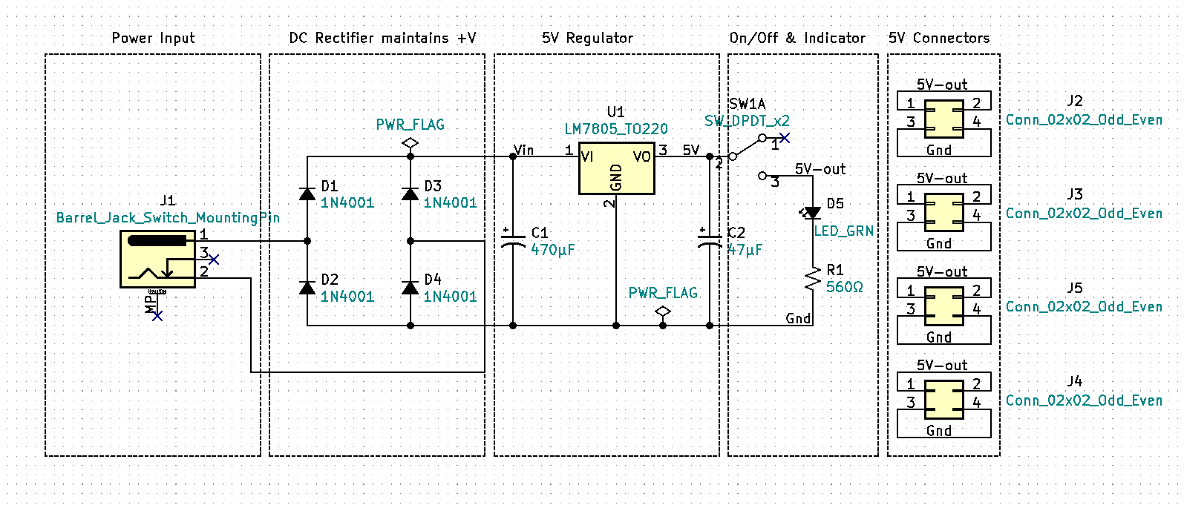 **Section 1 Introduction**

Figure 1-1 Breadboard Power Supply Schematic

In addition to the pandemic, Covid created an instant demand for online at home learning. Suddenly electronics students everywhere lost access to Laboratory Bench Test Equipment and the direct supervision of a Lab Instructor. Modestly priced oscilloscopes, function generators, and laboratory DC power supplies exist and I encourage advanced students to acquire these tools as they can. However, the introductory student will not likely have access to these type of tools at home and for them the Breadboard PS along with a DMM will provide an affordable and safe, at home circuit prototyping solution. 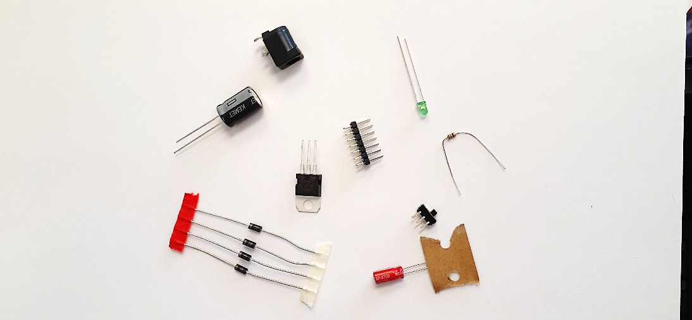 The electronic circuit design process involves defining a problem, determining a solution, circuit calculations & schematic development, acquiring the needed components, circuit testing (often referred to as breadboarding), PCB or printed circuit board development, PCB assembly, and final testing. Typically, the breadboarding stage is done using a bench top or Laboratory DC Power Supply. Once the breadboarding phase is complete and the circuit is functionally operational, we often need to replace the laboratory DC power supply with a dedicated power source. A power source can be as simple as a 9V battery or may be a dedicated high-power rack mount subsystem. Often, we can design our own power supplies using basic components rather than buying the off the shelf unit.

Figure 1-2 Electronic Components

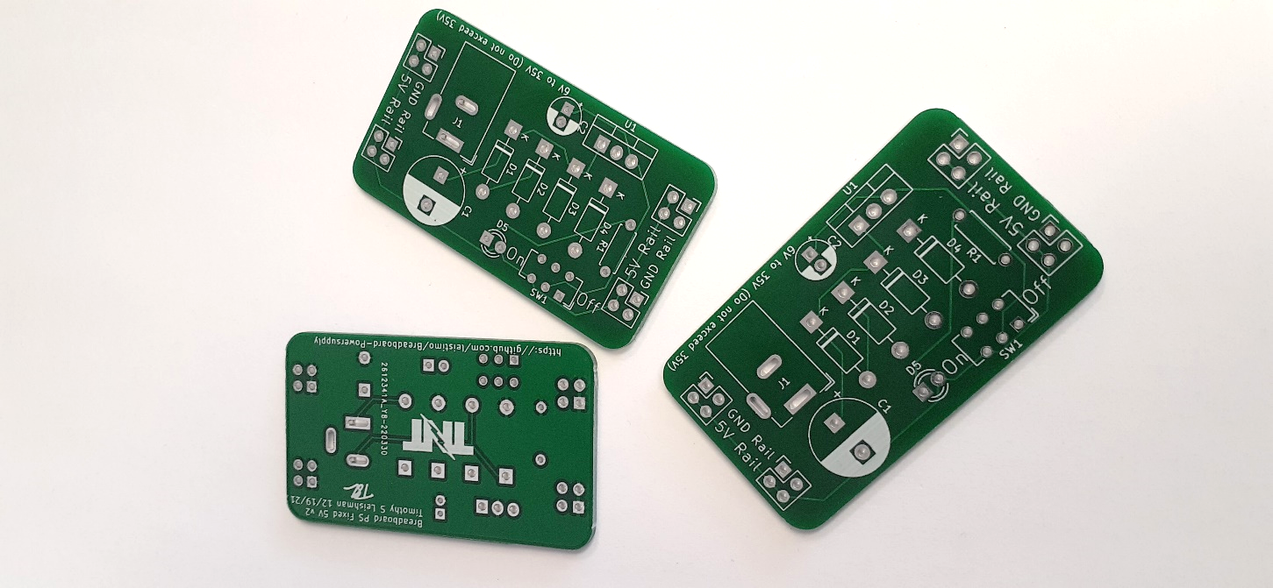While the power supply may not be the most exciting aspect of your electronic projects it is a crucial and foundational component. Poor power supply design can lead to intermittent circuit problems, premature circuit failures, and frustration. Understanding how power supplies operate and function will make you a better electronic troubleshooter. The Breadboard Power Supply will give you the ability to safely build and test circuits. This small project will also help you develop your soldering skills. Learning how to safely design and build dedicated power supplies will bring life to your current and future electronic projects.

Figure 1-3 Printed Circuit Boards (PCBs)

**Section 2 RMS & Peak Voltage**

The wall outlet at your house is 120-volt rms. 120vrms is dangerous. The circuit breaker at your house, which acts like a safety switch turning off the voltage, has the maximum current rating of 15 amps to 20 amps. Death can occur from as low as 100mA or 0.1A. The circuit breaker at your house is not designed to save your life from electrical shock, it is designed to prevent the wiring in your home from overheating heating and starting a fire. Do not mess 120v wall power it can kill you! For more safety information, here is a link to [OSHA’s Basic Electrical Safety](https://www.osha.gov/sites/default/files/2019-04/Basic_Electricity_Materials.pdf).

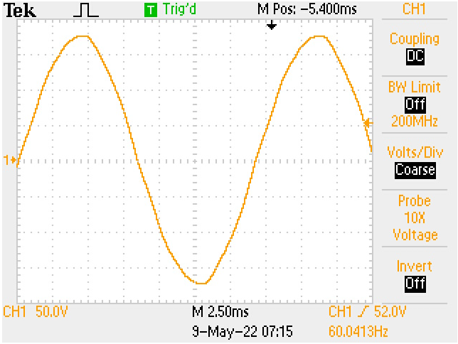Wall voltage is known as AC (Alternating Current). Most of what we do in electronics is DC (Direct Current). Examples of DC devices include: your computer, cell phone, Arduino, Raspberry Pi, and anything powered by a battery. The motor in your RC car is DC. However, some motors are designed to operate using single phase AC or industrial three phase AC. Because our wall power is AC and our electronic circuits are predominately DC we will need to convert the alternating wall current to direct current. The process of converting AC to DC is called Rectification.

Figure 4. shows a captured image of 120vRMS wall AC. An Oscilloscope displays voltage along the Y axis and time along the X axis. Observe that the Oscilloscope displays the image in alternating peak to peak voltage not RMS voltage.

Figure 2-1 120vrms waveform on oscilloscope

To convert peak to peak voltage to RMS voltage, the following formula can be used; $Vrms= \frac{Vp}{\sqrt{2}} OR Vp×0.707$. $Vp$ is peak voltage and is equal to $Vpp ($ peak to peak voltage) divided by two ( $Vp=\frac{Vpp}{2}$). In figure 5 note that channel 1 is set to 50 volts per division and the waveform, peak to peak, has approximately six major divisions and two half divisions equaling 7 major divisions. Now if we multiply $7div×50v/div$ we get a peak to peak voltage of $350vpp$. Dividing $350vpp$ by 2 gives us a peak voltage of $175vp$. Dividing $175vp$ by $\sqrt{2}$ gives an RMS voltage of $123.74vRMS or 120vRMS$. Peak voltage is important to understand when we are using an oscilloscope and calculating rectification circuits. RMS is useful for determining power. For example, the power calculations for an incandescent light bulb, audio amplifier, and ac motor would be calculated by multiplying the RMS voltage by the RMS current. Using RMS voltage to calculate ac power gives us an equivalent power for DC power calculations. Meaning $1vrms×1amp rms=1 watt$& $1VDC×1amp DC=1 watt$. 1 watt is the energy needed for each for both scenarios.

**Section 3 Voltage Rectification**

Voltage rectification is the process of changing AC (alternating current) to DC (direct current). Knowing that 100mA’s of current can be lethal and that in-general, skin resistance of a human is between 10KΩ & 1KΩ (1KΩ when wet), we can use Ohm’s Law, where $Current=\frac{Voltage}{Resistance}$, to determine a relatively safe voltage. If we convert 120vrms to peak we get $vp=120V×\sqrt{2}$ or $vp=169.71vp$. Now assuming we were able to rectify the 169.71volts we can use the human resistance of 1KΩ to determine the current potential, $i amps=\frac{169.71v}{1000Ω}$, $i=169.71mA$. This current is potentially lethal. If 100mA is our threshold for lethal current. What is the maximum “safe” voltage?

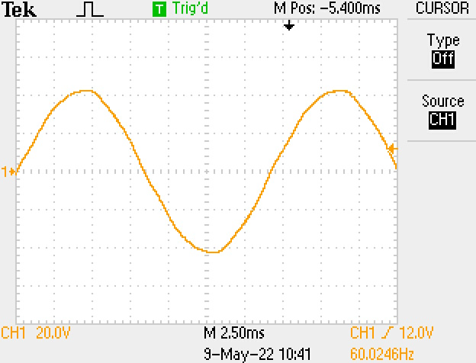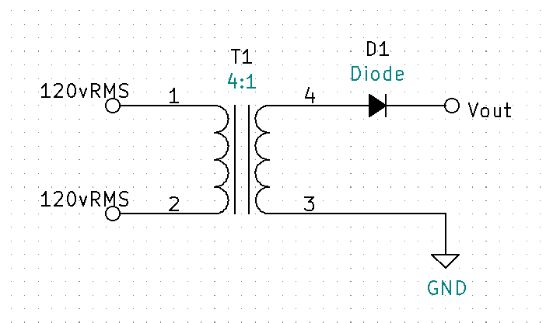Calculate the max voltage by $V_{max}=1KΩ×100mA$, $V_{max}=100v$. Now we know that 100v and above are potentially lethal voltages for humans, less than 100v should be less than lethal. Figure 5. shows a basic unregulated half-wave voltage rectifier circuit, transformer T1 is used for isolation and safety. Notice that T1 has a 4:1 turns ratio. T1 is a step-down transformer meaning that the primary side (pins 1 & 2) have four times more turns than the secondary side (pins 3 & 4). A step-down transformer’s secondary voltage will be divided by the turns’ ratio. For 4:1 transformer, $v_{Secondary}=\frac{V_{primary}}{4}=\frac{169.71vp}{4}=42.43vp$. Figure 6 shows the secondary voltage waveform of T1 pin 3 to pin 4.

Figure 3-1 Basic Half Wave Rectifier Circuit

The voltage has been stepped down to around 42vp. The waveform however, is still AC. Observe the frequency for both fig 4 and fig 6. Frequency is measured in hertz (Hz) and both the primary and the secondary are measuring the same at 60Hz which is the standard frequency for AC power in the United States.

Figure 3-2 Secondary Waveform Voltage of 4:1 Transformer

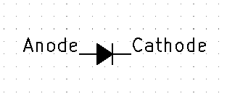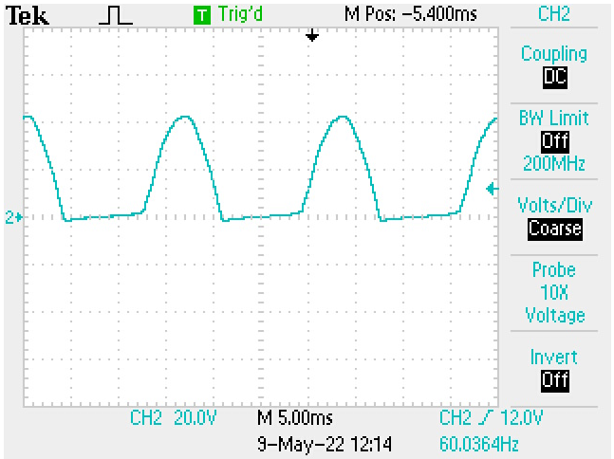The diode D1 of Figure 5. will provide rectification by acting like a switch and allowing current to flow in only one direction. When the anode is positive with respect to the cathode, current will flow. When the anode is negative with respect to the cathode the diode will act like an open and no current will flow. The output waveform will now appear to have the negative peaks clipped off (See fig. 8). The current is flowing in one direction and basic half-wave rectification has been achieved. Notice the waveform frequency is still 60Hz for half-wave rectification.

Figure 3-3 diode anode and cathode

Figure 3-4 half-wave rectification

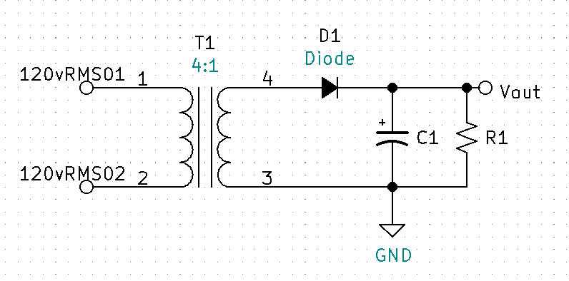 **Section 4 Capacitive Filtering & DC Calculations**

Figure 4-1 basic unregulated rectifier with filtering

By adding a filtering capacitor, we can smooth the ripple waveform to make it more like DC. Figure 9 has added a filter capacitor C1 and load resistor R1. The capacitor will charge immediately when the diode D1 is forward biased. When the diode becomes reverse biased the capacitor will discharge through the load R1. With a large enough capacitance value and load resistor the output will be a smooth DC. We can test this by using a 10uF capacitor with no load, 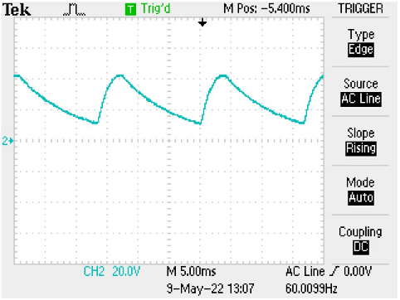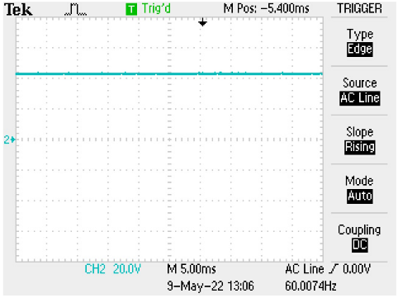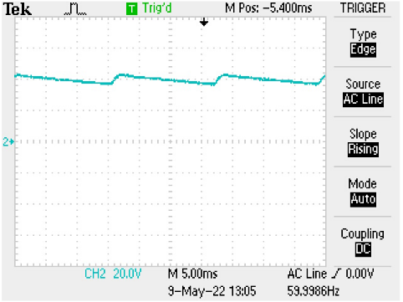a 10KΩ load, and a 1KΩ load to show the varying degrees of ripple (see figures 10, 11, & 12).

Figure 4-4 1K ohm load

Figure 4-3 10K ohm load

Figure 4-2 no load

When there is ripple present on the waveform, VDC can be thought of as the average waveform voltage. VDC can be calculated by adding the maximum positive peak voltage to the minimum peak voltage and then dividing the sum by two.

Example Calculate $V_{DC}$ for figure 12:

$V_{DC}=\frac{V_{max}+V_{min}}{2}$

$V_{max}=2.1 div×{20v}/{div}=42v$

$V_{min}=0.5 div ×{20v}/{div}=10v$. Now find $V_{DC}$.

${VDC}_{1KΩ}=\frac{V_{max}+V_{min}}{2}= \frac{42v+10v}{2}=26V$.

**Section 5 Voltage Regulation**

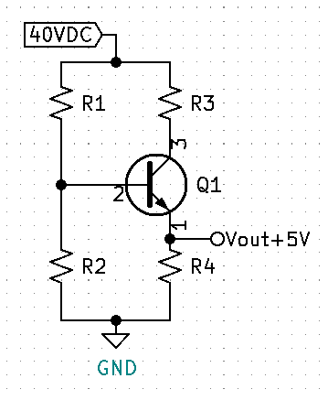For Figures 10-12, observe that as the load is increased (Ohm’s law $I=\frac{V}{R}$, current or “load” increases as resistance is decreased), the ripple voltage waveform increases and as the ripple increases the effective DC voltage is decreased. This is an example of a rectifier circuit that is Un-Regulated. An un-regulated power supply’s DC voltage will decrease as the circuit load current is increased.

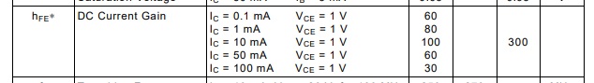 For many circuits having an unregulated power supply is a problem. Voltage regulation is required for any circuit that requires smooth consistent DC voltage across varying loads or current demands. Figure 13 shows a common collector amplifier which can be used to provide basic voltage regulation. To calculate the needed resistors R1 thru R4, an output voltage must be determined. Next, determine the maximum current need for your circuit. For this example, we will use 5V with a maximum current need of 5mA. Calculate the base current (pin 2) of the transistor by dividing the 5mA emitter current (pin 2) by the minimum beta (aka hfe) per the data sheet. For the 2n3904. The minimum hfe for the 2n3904 with a collector current near 5mA will be will be between 80 and 100, see figure 14.

Figure 5-2 beta for a 2n3904 transistor

Figure 5-1 Basic Voltage Regulation Circuit

$I_{B}≈\frac{5mA}{90}≈55.556μA$

With IB known, make IR2 a minimum of 10 times larger.

$I_{R2}≥(10×I_{B)}≥(10×55.556μA)≥555.556μA$

Use Kirchhoff’s Voltage Law to calculate VR2.



$V_{R2}=V_{R4}+V_{BE}=5V+0.7V=5.7V$

Use Ohm’s Law to calculate R2

$R_{2}=\frac{V_{R2}}{I_{R2}}=\frac{5.7V}{min555.556μA}=10.26KΩ$

* Round down to next standard value, $R_{2}=10KΩ$

Recalculate IR2 using standard value.

$I_{R2}=\frac{V_{R2}}{R_{2}}=\frac{5.7V}{10KΩ}=570μA$

Calculate IR1 using Kirchhoff’s Current Law.

$I_{R1}=I_{B}+I_{R2}=55.556μA+570μA=625.556μA$

Calculate VR1 using Kirchhoff’s Current Law.

$V_{R1}= V_{CC}-V_{R2}=40V-5.7V=34.3V$

Calculate R1 using Ohm’s Law.

$R_{1}=\frac{V_{R1}}{I_{R1}}=\frac{34.3V}{625.556μA}=54.831KΩ$

R3 is used to help split the power from the transistor. Power for the transistor is calculated using the max current multiplied by VCE.

* + Now make $V_{CE}= \frac{V_{CEmax}}{2}=\frac{35}{2}=17.5V$

$P_{Q1}=I_{Cmax}×V_{CE}=5mA×17.5V=87.5mW$

Calculate VR3 using Kirchhoff’s Voltage Law.

$V_{R3}=VCC-VCE-VR4=40V-17.5V-5V=17.5V$

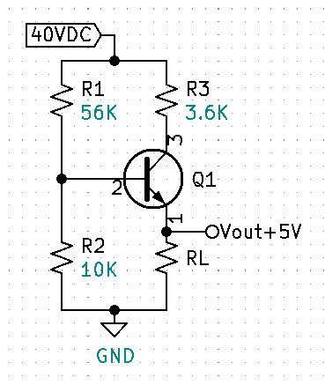Calculate IR3.

${IR}_{3}≈5mA$

Calculate R3 using Ohm’s Law.

$R_{3}=\frac{V_{R3}}{I_{R3}}=\frac{17.5V}{5mA}=3.5KΩ$

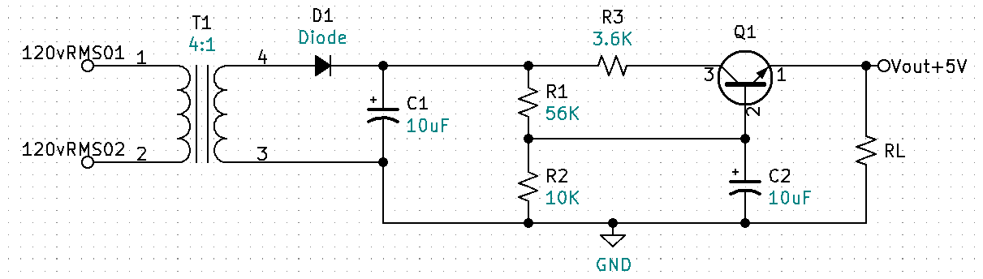Figure 16 displays the regulation circuit with standard values. Figure 16 shows the entire rectification circuit with the voltage regulation added. Notice the second 10uF capacitor C2 at the base of the transistor. This is used to keep the voltage and current at the base of the transistor extra stable. Figure 16 transistor orientation is also drawn in the more typical manner for a power supply.

Figure 5-4 Basic Rectification Circuit with Voltage Regulation

Figure 5-3 Basic Regulation Circuit with Standard Values.

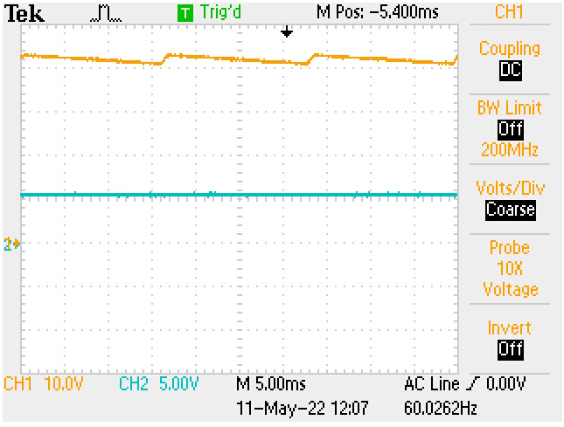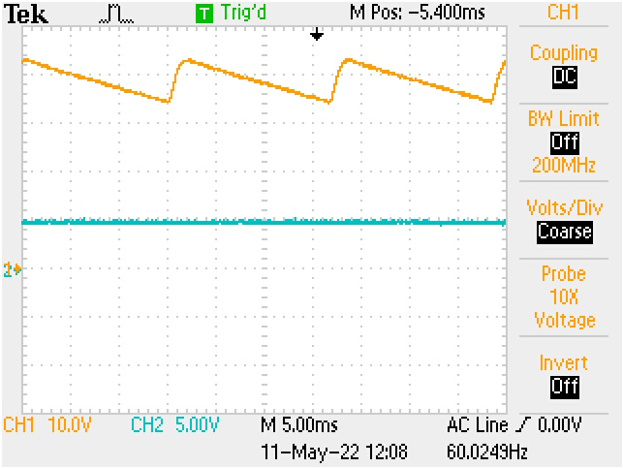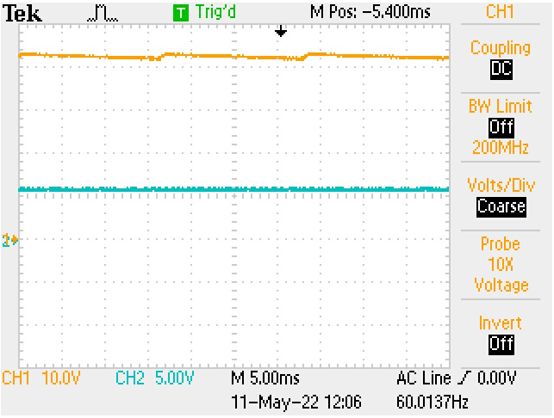

Figure 5-7 CH2 regulated Vout, 1K ohm load

Figure 5-6 CH2 regulated Vout, 10K ohm load

Figure 5-5 CH2 regulated Vout, no load

Observe Figure 17, 18, & 19. CH1 is the rectified input voltage across capacitor C1. CH2 is the regulated output which maintains a consistent DC voltage with no ripple from no load to a 1KΩ load. If you look closely you can see a very small and tolerable shift in the DC level (approximately 0.5V) from no load to 1k. Now let’s practice what we have learned by designing basic 5VDC regulator using a 9VDC battery.

**Section 6 Your First Power Supply Project**

We learned previously that the human body skin resistance is around 1KΩ when wet and 10KΩ when dry. We also learned that a current of 100mA is potentially lethal. If we use a 9VDC battery as our voltage source, what is the maximum current through wet skin and minimum current through dry skin potential exposure? (use Ohm’s Law)

* Wet skin: ${ I}_{wet}=\frac{V}{R}=\frac{9V}{1KΩ}=9mA$
* Dry skin: $I_{dry}=\frac{V}{R}=\frac{9V}{10KΩ}=900μA$

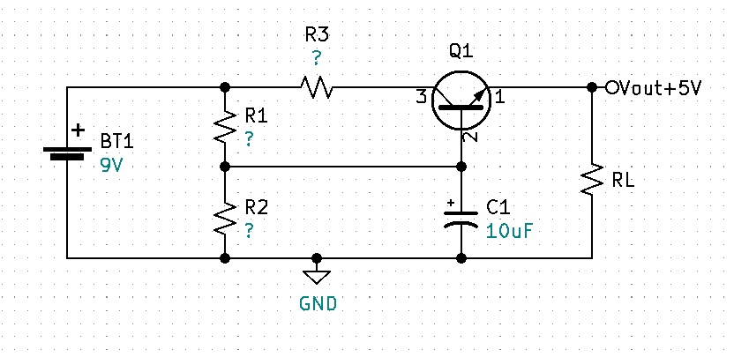 With dry skin you will not be able to feel or perceive the less than 1mA of current from a 9V battery. If wet however, you could potentially feel a non-lethal shock. Additionally, remove all metal jewelry prior to working with any electronics. Metal jewelry can cause severe burns even when working with low voltage.

Figure 6-1 5V regulator using a 9V source

**First Challenge:** Calculate and find the resistor values for the circuit in Figure 20. to produce a regulated 5V output with a max current of 5mA, assume Q1 is a 2n3904 with a minimum beta of 90.

**Solution for First Challenge:**

Find the maximum base current IB for Q1.

$I_{Bmax}≈\frac{I_{Emax}}{{Beta}_{min}}≈\frac{5mA}{90}≈55.556μA$

Make IR2 $≥$ 10 x IBmax.

$I_{R2}≥10×55.556μA≥555.556μA$

Find VR2 using Kirchhoff’s Voltage Law.

$V_{R2}=V_{BE}+V_{RL}=0.7V+5V=5.7V$

Find approximate R2 value using Ohm’s Law.

$R_{2}≤\frac{V_{R2}}{I_{R2}}≤\frac{5.7V}{555.556μA}≤10.26KΩ$

Round R2 value down to a standard value.

$R_{2}=10KΩ$

Recalculate IR2 using Ohm’s Law.

$I_{R2}=\frac{V_{R2}}{R_{2}}=\frac{5.7V}{10KΩ}=570μA$

Find IR1 using Kirchhoff’s Current Law.

$I_{R1}=I_{R2}+I_{B}=570μA+55.556μA=625.556μA$

Find VR1 using Kirchhoff’s Voltage Law.

$V_{R1}=V_{BT1}-V_{R2}=9V-5.7V=3.3V$

Calculate R1 using Ohm’s Law.

$R_{1}=\frac{V_{R1}}{I_{R1}}=\frac{3.3V}{625.556μA}=5.28KΩ$

Determine R3. First ask yourself what the total power of Q1 is without R3 and if that power needs to be split?

$P_{Q1}=I_{Cmax}×VCE$

$V_{CEmax}= V_{BT1}-V_{RL}=9V-5V=4V$

$I_{Cmax}=5mA$

$P_{Q1}=I_{Cmax}×VCE=5mA×4V=20mW$

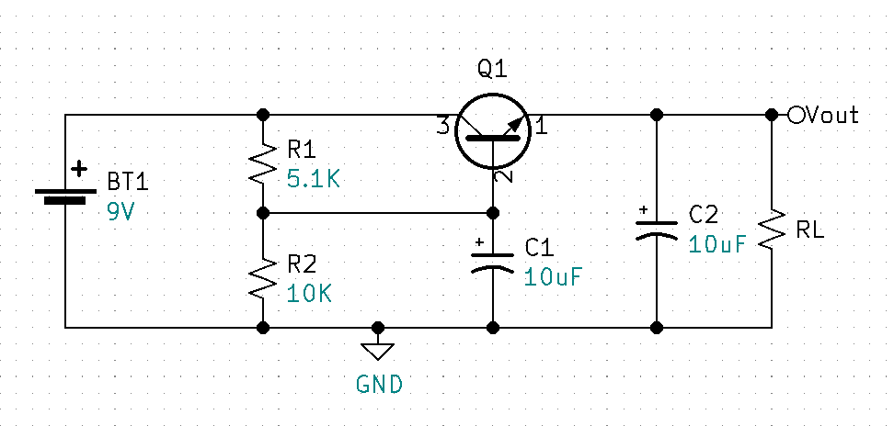The absolute maximum power rating for a 2N3904 is 625mW. Optimal power operation for the 2N3904 will be less than or equal to half the absolute maximum rating, approximately 300mW. Because we are well below the optimal power operation at 20mW, R3 is not required for this circuit.

Figure 6-2 Test Circuit - R1 Standard Value, Additional Filter Cap C2.

With Figure 21 assembled and tested, the output measured a smooth 5.04V with a 1KΩ load resistor and 5.44V with no load. This circuit works good for a specific input voltage, in this case 9VDC. Let’s say we want to design a circuit that has the ability to accept a variety of input voltages instead of just 9V. How might we deal with a range of input voltages and still maintain a regulated output of 5V?

**Section 7 Zener Regulation**

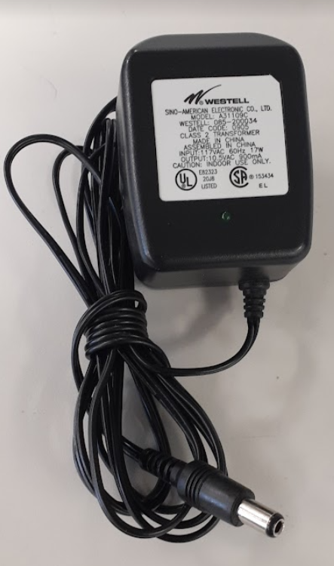 If you are like me, you have a box full of salvaged electronic components. I have one dedicated to wall ACDC power adapters as seen in Fig. 23. These wall adapters, sometimes referred to as “wall warts” take care of voltage rectification for us by internally converting the 12Vrms AC voltage to a fixed DC voltage. Typically, the output voltage and current specifications are written on the adapter. The adapter in Fig 22. is listed as having an output of 10.5V that can supply up to 900mA. Let’s say I also have a wall adapter that has a 12V output and third that has a 20V output. Can we design a single circuit that will accommodate each of those inputs and still provide a regulated 5V output? By replacing R2 in our previous circuit with a Zener diode we can achieve regulation throughout a range on input voltages.

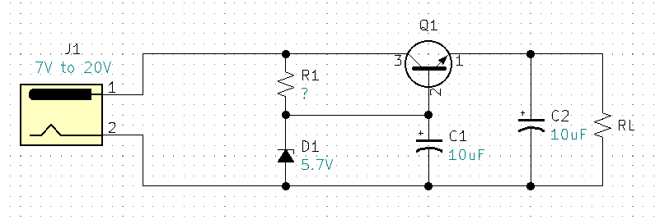

Figure 7-2 Zener regulation circuit with barrel jack input

Figure 7-1 AC to DC wall power adapter

with barrel jack connector

R1 Calculations for Fig 23:

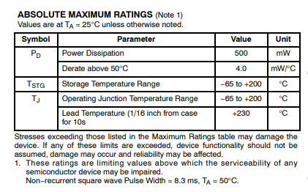 Ideally D1 would be a 5.7V Zener, I had on hand a 1N5233 6V Zener diode. There are two important specifications we need to know, the maximum Zener current ($I_{ZM}$) and the minimum Zener current known as knee current ($I_{ZK}$). According to the data sheet the maximum power for my Zener is 500mW. With this information we can calculate $I_{ZM}$.

Figure 7-3 Data Sheet Excerpt for 1N5233

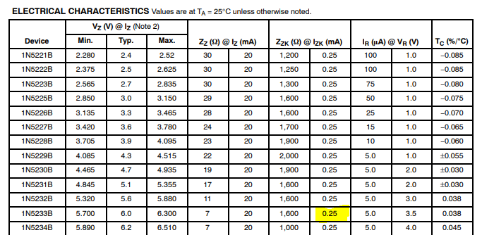 Calculate $I_{ZM}$ using the power formula.

Figure 7-4 Data Sheet IZK

$P=I×V$

$I=\frac{P}{V}$

$I_{ZM}=\frac{P_{ZMax}}{V_{Z}}=\frac{500mW}{6V}=83.333mA$

According to the data sheet $I_{ZK}=0.25mA for the 1N5233 Zener$ diode.

You can determine your minimum input voltage by adding a minimum of two volts to your regulated output voltage. This extra voltage is needed for the linear regulator to have at least two volts VCE across the transistor. The transistor will lose regulation if its VCE drops too low. For our example with a 5V output we would need a minimum of a 7V input. Now imagine that the input is 7V and the 6V Zener is doing its job. Using Kirchhoff’s Voltage Law, we can see that VR1 will equal 1V. Here is the math.

With the input Voltage set to 7V:

$V_{R1}=V_{in}-V_{Z}=7V-6V=1V$

We know that the Zener needs a minimum current of $I_{ZK}$ therefore:

* $R_{1}=\frac{V_{R1}}{I_{ZK}}=\frac{1V}{0.25mA}=4KΩ$, round down to next standard value of 3.9KΩ

With the maximum input voltage of 20V chosen, verify $I_{Z}$ does not exceed $I_{ZM}=83.333mA$.

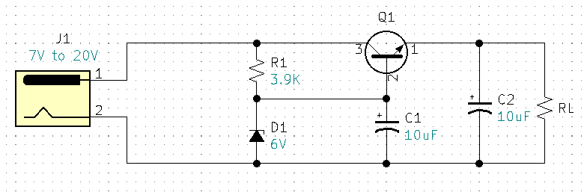With the input Voltage set to 20V:

Figure 7-5 Zener Regulated Circuit

$V_{R1}=V_{in}-V_{Z}=20V-6V=14V$

$I_{Z}=\frac{V_{R1}}{R_{1}}=\frac{14V}{3.9KΩ}=3.59mA$

* $I_{Z}$ is less that $I_{ZM}$, and within specifications.

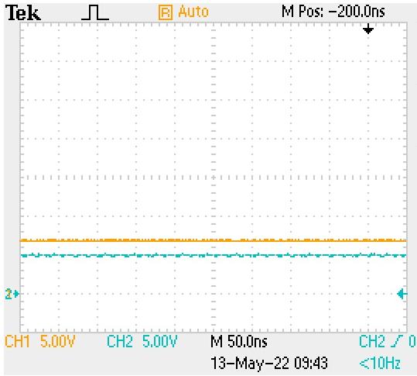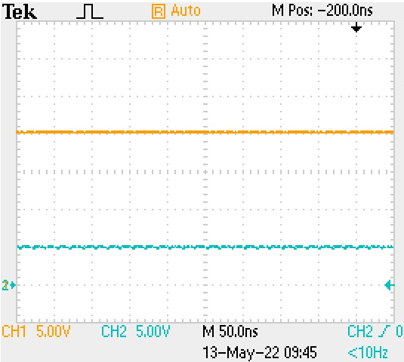One more calculation that should be verified is Q1 power when the input is at 20V.

Figure 7-6 Measured, Ch1 7V input & Ch2 5V output.

Figure 7-7 Measured, Ch1 20V input & Ch2 5V output.

$P_{Q1}=I_{RLmax}×V_{CE}$

$I_{RLmax}=5mA$

$V_{CEmax}=V_{INmax}-V_{RL}=20V-5V=15V$

$P_{Q1}=I_{RLmax}×V_{CE}=5mA×15V=75mW$

$P_{Q1}=75mW is less the maximum power for a 2N3904, P_{Max2N3904}=625mW$

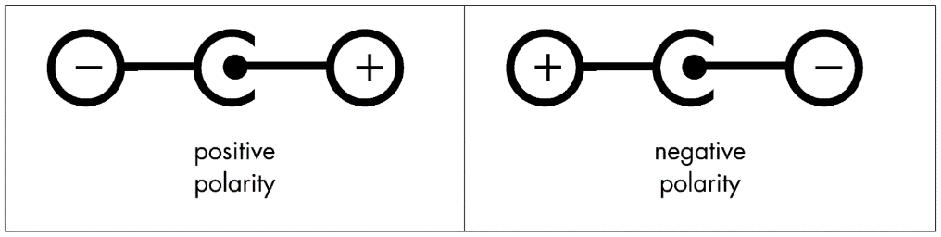 With Zener regulation we can now regulate a range of input voltages. But only barrel jack connectors that have a positive center pin. Have you ever noticed the symbol markings on your AC wall adapters similar to Fig. 29? In my box of salvaged adapters, I have some unmarked, some center positive, and some center negative. Currently, we could damage our circuit, or the wall adapter, if we used unmarked or center negative adapters. How could our circuit be fix so that it could accept both positive and negative center polarities and still output a fixed +5V?

Figure 7-8 Barrel Jack polarity markings

**Section 8 Input Polarity Correction**

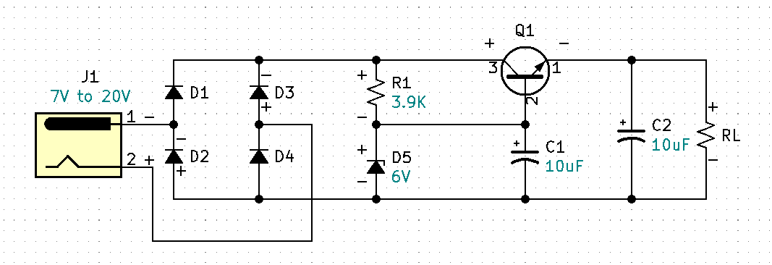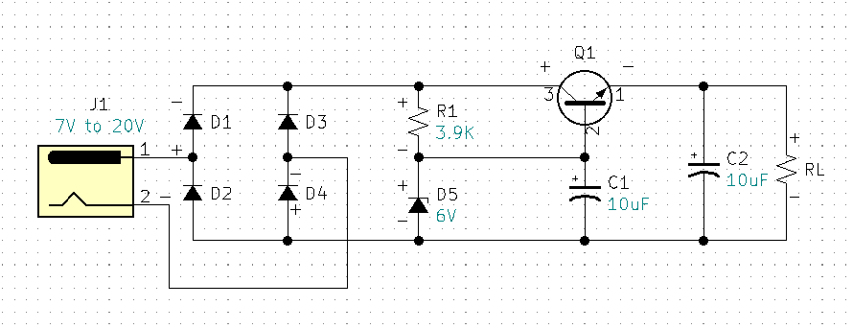 Similar to how we used diodes in our AC to DC voltage rectification circuit, we can use diodes to provide DC polarity correction. For this example, I am using 1N4001 general purpose diodes for D1-D4.

Figure 8-2 Input Polarity Correction, J1 Pin1 Negative.

Figure 8-1 Input Polarity Correction, J1 Pin1 Positive.

Observe Figure 31 when J1 pin 1 is positive with respect to pin 2, diodes D1 and D4 are forward biased and diodes D2 and D3 are reverse biased and acting like open switches. The result is the rest of the circuit is properly biased. Observe Figure 32 when J1 pin 1 is negative with respect to pin 2, diodes D2 and D3 are forward biased and diodes D1 and D4 are reverse biased. The result is the rest of the circuit is again properly biased. Therefore, the circuit is now adapted to receive either positive, negative, or unknown voltage polarities. This circuit makes virtually all of our salvaged wall adapters useable. I assembled and tested the circuit with +20VDC input measured +5.08VDC at the output with a 1KΩ load. I also tested with -20VDC input and measured +5.08VDC at the output with a 1KΩ load.

What happens to this circuit if the output is shorted? The answer is the transistor will exceed its power specifications and destroy itself. None of the previous circuits have current limiting protection. If you are building a dedicated circuit that will be deployed with a fixed load and a fixed input voltage, and you can guarantee that the output will never be shorted, the previous circuits may work fine. However, current limiting circuit protection is always a good idea. What might be a simple way to apply current limiting protection to this circuit?

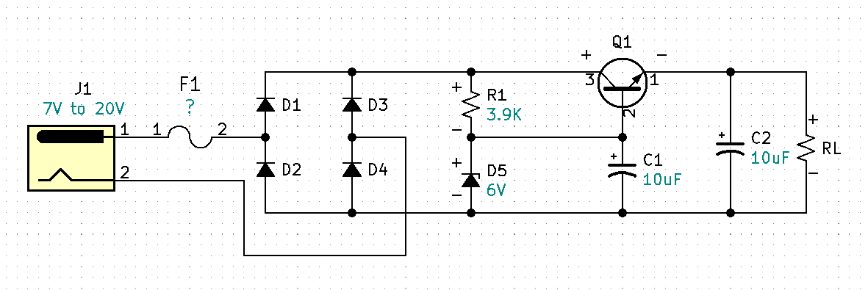 **Section 9 Basic Current Limiting Protection**

Figure 9-1 Simple current limiting protection provided by F1 fuse.

A fuse can provide basic current limiting protection for your circuit. To determine the proper fuse value, we need to consider all the parts that will be affected when the output is shorted or overloaded. We can see that Q1 and the polarity correction diodes are in the direct path between the voltage source and the output. Additionally, we should consider the output rating on the AC/DC wall adapter. All wall adapters will be rated differently. As previously mentioned, my adapter is rated at 900mA. According to the data sheet the 1N4001 diodes are rated at a maximum forward current of 1A. And the 2N3904 BJT is rated at an absolute maximum forward DC current of 200mA. So, for this circuit we will need to protect the weakest link which is the 2N3904 BJT at 200mA. If your wall adapter is rated less than 200mA, your fuse choice would be based on that current. Because 200mA is the absolute maximum, we will want to guarantee that the current stays well below 200mA. Our circuit is designed to run at 5mA so our fuse will need to be larger than 5mA and well below 200mA. An appropriate fuse for this 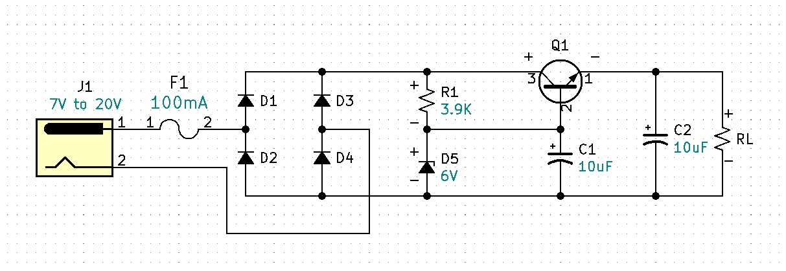circuit is a slow blow 100mA or 0.1A fuse.

Figure 9-2 Fuse F1 = 100mA or 0.1A

We know the transistor Q1 can handle a forward current of 100mA. We need to recalculate the transistors power with a load current of 100mA and determine if the power at Q1 is still in specification.

New Calculations:

$R_{L@100mA}=\frac{V_{RL}}{I_{RL}}=\frac{5V}{100mA}=50Ω$

$P_{Q1@100mA}=V_{CEmax}×I_{Cmax}$

$V_{CEmax}=V_{INmax}-V_{RL}=20V-5V=15V$

$I_{Cmax}=F1=100mA$

$P_{Q1@100mA}=V_{CEmax}×I_{Cmax}=15V×100mA=1.5 watts$

$P_{Q1}$ at 1.5 watts is too high for the 2N3904. There are two ways we could deal with this problem. The first is to do a power split by adding a series parasitic power resistor in the path of the collector of the transistor just like we did previously with R3 in the rectifying circuit Fig. 15. The second option is the Darlington Pair.

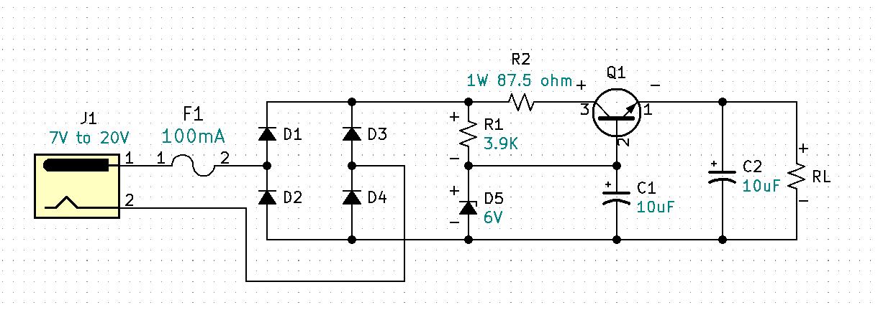First let’s calculate the parasitic power resistor.

Figure 9-3 Parasitic R2 power protection for Q1

$P_{total}=1.5 watts$

$P_{Q1max}=625mW$

$P_{R2max}=P_{total}-P_{Q1max}=1.5 watts-625mW=875mW$

$V_{R2}=\frac{P_{R2max}}{I_{Cmax}}=\frac{875mW}{100mA}=8.75V$

$R_{2}=\frac{V_{R2}}{I_{Cmac}}=\frac{8.75V}{100mA}=87.5Ω$

The circuit Fig 34 will work fine when the load is 5mA. However, now that know we can operate up to 100mA without damaging any of the parts, a problem has been introduced via R2. Can you spot the problem? If we want to operate our output at 99mA, what is the required input voltage for Fig 34.?

Calculate the required input voltage when the output is running a 99mA load.

$V_{in}=V_{D1}+V_{D4}+V_{R2}+V_{CE}+V_{RL}$

$V_{D1\&D4}=0.7V$

$V_{R2}=I_{C}×R_{2}=99mA×87.5=8.663V$

$V_{CEmin}=2V$

$V_{RL}=5V$

$V_{in}=0.7+0.7+8.663+2V+5V=17.063V$

$V_{in}=17.063V$

A Vin requirement of 17V for our circuit is not practical. Using this method would severely limit the flexibility of this circuit. A preferable method is to use a Darlington Pair with a higher-powered transistor.

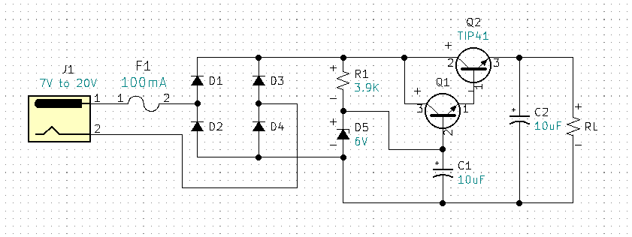 **Section 10** **The Darlington Pair**

Figure 10-1 5V Regulator with Darlington Pair.

The Darlington Pair is a current multiplier. The power transistor TIP 41 is able to handle more power than the 2N3904. Here is a question you may be thinking, why not omit the 2N3904 Q1 transistor and replace it with the power transistor TIP41? The answer is, power transistors have a much lower beta or hfe than general purpose transistors. Therefore, our base current would go up significantly and we would still need 10X current through the Zener. We would also need to keep our IZ current below IZM. Additionally, the increase in IZ would require a recalculation of the R1 value to accommodate the increase in current. This would negatively impact our efficiency, we don’t want more quiescent current to go directly to ground through the Zener. Imagine if your power supply was battery powered, an increase in IZ would discharge your 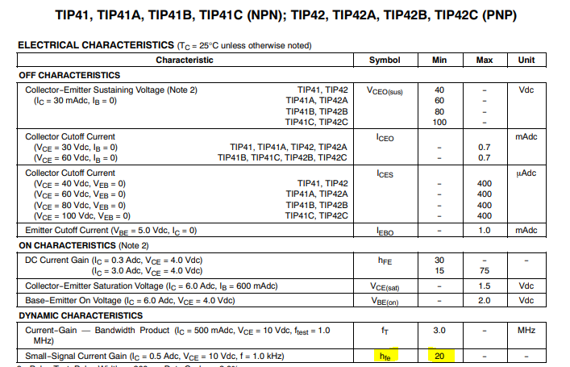battery faster. By adding the Darlington, we can keep the current through the Zener significantly lower, while increasing the current through the load. With the Darlington Pair, if the circuit was run at its maximum current of 100mA, what would the current at the base of Q1 be?

* $R_{L}=\frac{V}{I}=\frac{5V}{100mA}=50Ω$:

Figure 10-2 Beta for a TIP41 transistor.

$I_{RL}=\frac{V_{RL}}{RL}=\frac{5V}{50Ω}=100mA$

${IE}_{Q2}=I_{RL}=100mA$

* ${IB}_{Q2}≈\frac{{IE}_{Q2}}{TIP41{Beta}_{min}}≈\frac{100mA}{?}$ (see fig 36 for beta/hfe min)

${IB}_{Q2}≈\frac{100mA}{20}≈5mA$

${IE}_{Q1}≈{IB}_{Q2}≈5mA$

${IB}_{Q1}≈\frac{{IE}_{Q1}}{2N3904{Beta}_{min}}≈\frac{5mA}{90}$

${IB}_{Q1}≈\frac{{IE}_{Q1}}{2N3904{Beta}_{min}}≈55.556μA$

Note, our output prior to the Darlington Pair was designed for a maximum 5mA, we decided to increased output load capability to 100mA. This is a current gain or increase of 20. Adding the Darlington pair with a TIP41 power transistor solved two problems. The first was the TIP can handle the increased circuit power and the second the TIP41 with its minimum beta of 20 gave the Darlington a current magnification factor of 20, keeping the base current of Q1 and IZ the same which allows R1 to remain the same.

I assembled and tested the regulator circuit fig. 35. The circuit was tested with 20V & 7V inputs and with 1KΩ & 50Ω loads. The circuit performed as expected with a regulated output of 5V for each scenario. This circuit works great however, we should consider the limitations and associated cost. For Q2 power over two watts the TIP41 will require a heat sink. A heat sink will be an relatively expensive component. The TIP41 itself cost is just under a dollar. The Zener diode, the fuse and a fuse holder also add cost. Is there a single component that could replace the fuse, fuse holder, Zener diode, and both Bipolar Junction Transistors? We can purchase an off the shelf, dedicated, all in one 5V (and other standard values) linear voltage regulator for less than a dollar!

**Section 11** **The L7805 Regulator**

The L7805 is a 5V fixed linear regulator with internal current limiting and temperature protection. The L7805 is part of a L78 series of linear regulators. The L78 series can be purchased as 5V, 6V, 8V, 8.5V, 9V, 12V, 15V, 18V, and 24V regulators. One point to understand is linear regulators can only regulate down, they cannot regulate up. For the L7805 5V regulator the input voltage can be minimum of 6V to an absolute maximum voltage of 35V. At the time of writing this document I can purchase a L7805 for $0.62.

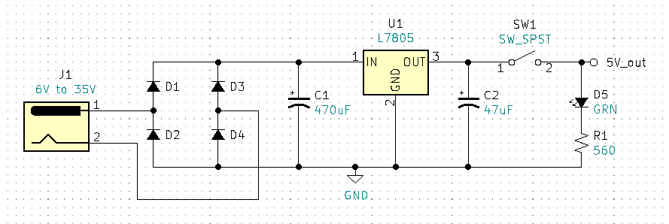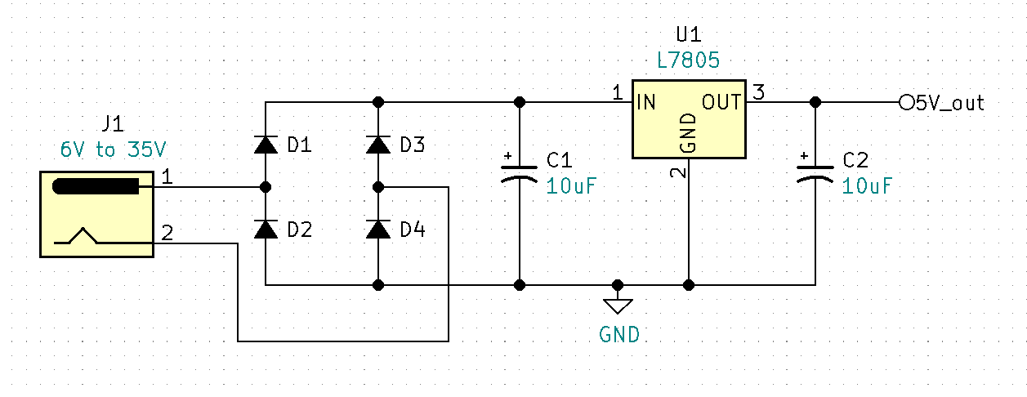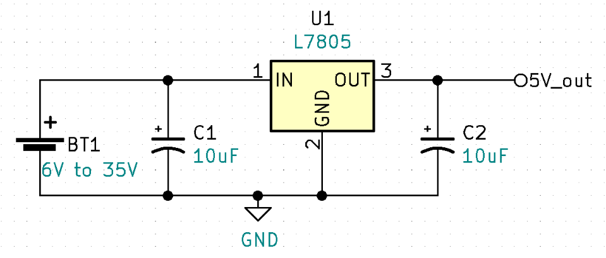 Notice that in Fig 38 circuit the fuse has been removed. This is because the L7805 has internal current limiting and over temperature protection which will provide adaquate protection for the circuit. Diodes D1 – D4 provide polarity correction, ensuring that pin1 of the L7805 is always positive.

Figure 11-3 Final circuit with SW1 and power indication

Figure 11-1 L7805 Linear 5V Regulator basic test circuit

Figure 11-2 L7805 Linear 5V Regulator with Barrel Jack input and Polarity Correction

Figure 39. is the final circuit. The capacitor values were increased for additional filtering. SW1 was added for switchable output voltage. The logical position for this SW1 would have been at the input. However, this project has a small size or form factor and the micro switch is used is rated at 6V, so the problem with putting the switch in series with J1 is that it would be out of specification due to overvoltage. The problem with SW1 current position is the quiescent current of the L7805when the barrel adapter is plugged in and powered. Linear Regulators are inefficient when compared to Switch Mode Power Supplies. The inefficiency of the L7805 is due to the fact that the regulator requires a certain amount of current to operate even if there is no load at the output. This would be comparable to the Zener current in the previous circuit. This current is called Quiescent Current and the typical quiescent current, per the data sheet, for a L7805 is 3.2mA. If you are using a 9V battery and a barrel adapter to power your breadboard circuit you will need to unplug the barrel jack after circuit testing to ensure the battery does not drain down. The typical 9V battery is rated at 500mAh, meaning if you run the battery at 500mA, it will be drained in one hour. So, if our linear regulator requires 3.2mA and we have no load (no current) at the output, how long will it take to drain the 9V battery?

$500mA=1hour, 3.2mA=x hours?$

$x=\frac{5oomA×1hour}{3.2mA}=156.25 hours$

If you leave your 9V battery plugged into the breadboard power supply with no load at the output, you will have a dead battery after 156 hours. I considered not having a switch at all, thus making the circuit even simpler, and forcing the operator plug and unplug the barrel jack. However, I like having the ability to switch on and off the 5V GND rails on the breadboard and the goal of this project was to be able to use salvaged barrel jack ACDC wall adapters.

The green LED D5 provides on/off output indication. The maximum current rating for the LED is 30mA. The forward voltage for this green LED is approximately 2V. This leaves us 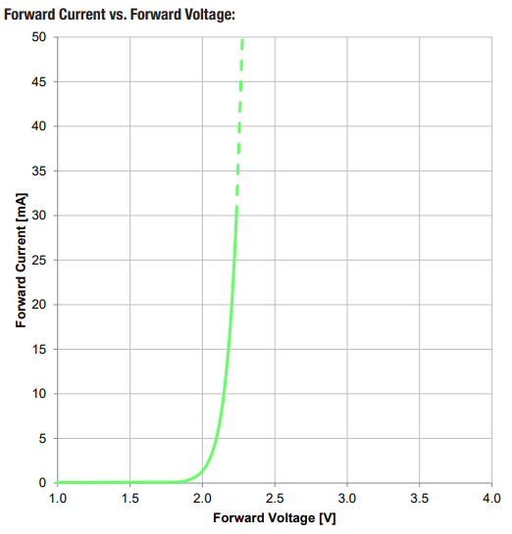with 3V across the current limiting resistor R1. What is the minimum resistance that R1 can be without exceeding the diodes 30mA max current?

${R1}_{min}=\frac{3V}{30mA}=100Ω$

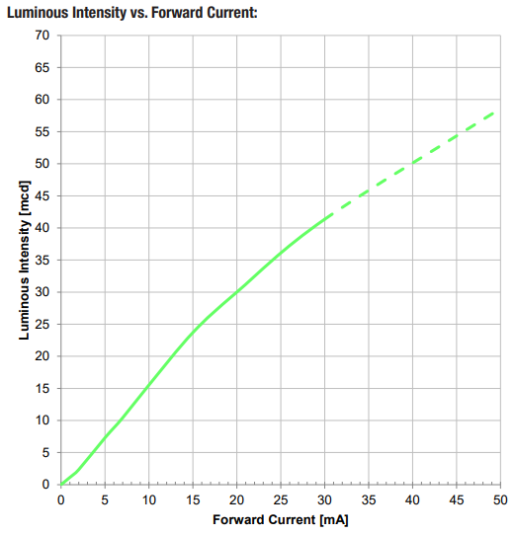As R1’s resistance value is increased, the LEDs forward current will decrease, and the LEDs luminous intensity will decrease. Bench testing found that a 560Ω resistor provides a minimum current with adequate LED illumination.

Figure 11-5 LED Intensity vs. Forward Current

Figure 11-4 LED Forward Current vs. Forward Voltage

**Section 12 Breadboard Power Supply Assembly**

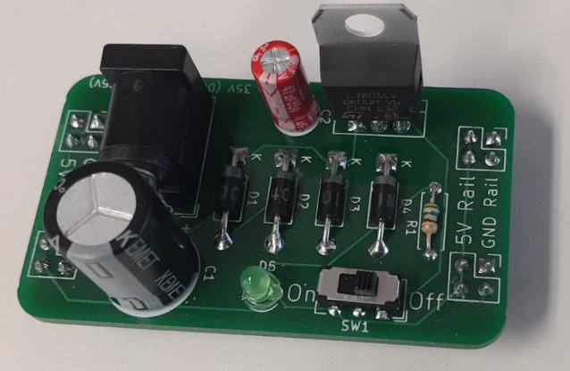

Figure 12-1 Fully Assembled Breadboard Power Supply

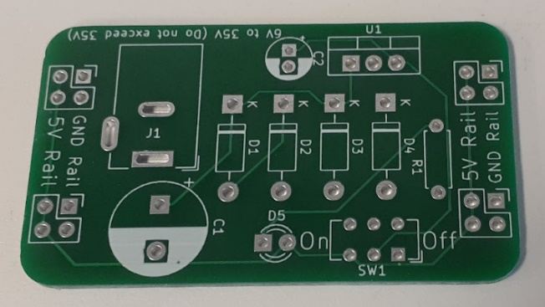

Figure 12-2 PCB with no parts

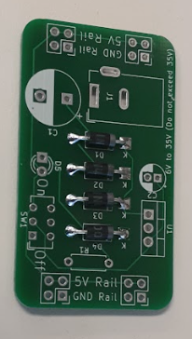 Start by soldering diodes D1 – D4. Make sure the orientation is correct, the silver band is the cathode and goes toward the K.

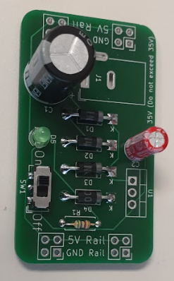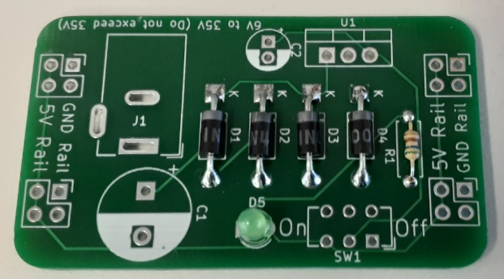 Solder R1, orientation is not important. D5 the LED must be soldered with the proper orientation. There is a flat side on the collar of the LED, this flat side should be associated with the short lead. The short lead and flat side collar should be soldered to the square pad. The long lead of the LED goes to the round pad, toward SW1.

Figure 12-3 Add polarity correction diodes

Figure 12-4 Add the power indication circuit, LED & R1

The electrolytic capacitors are polarity sensitive and must be installed correctly. Solder the negative pin to the round pad with the white and the positive pin to the square pad.

Figure 12-5 Add Filter Capacitors

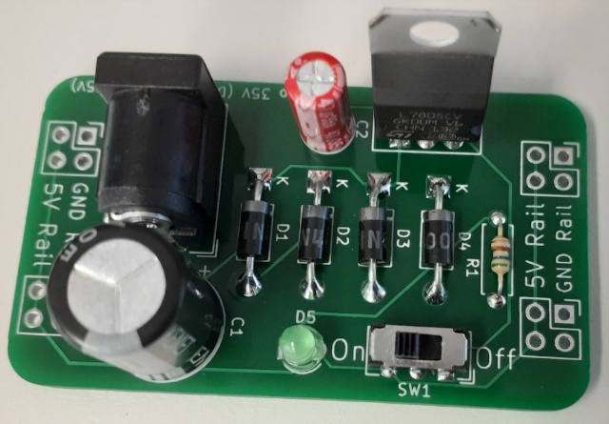 The barrel plug input adapter has kinked pins. At first this part can be a little difficult to get into position. Make sure to align the pins and then press hard and it should snap into place. Orientate the L7805 as seen in the picture, front to the circuit and back to open space.

Figure 12-6 Add Barrel Plug Adapter and the L7805 Regulator

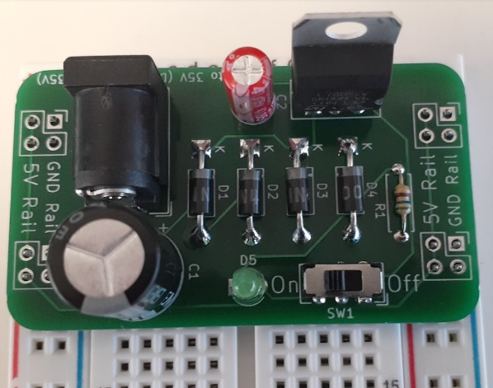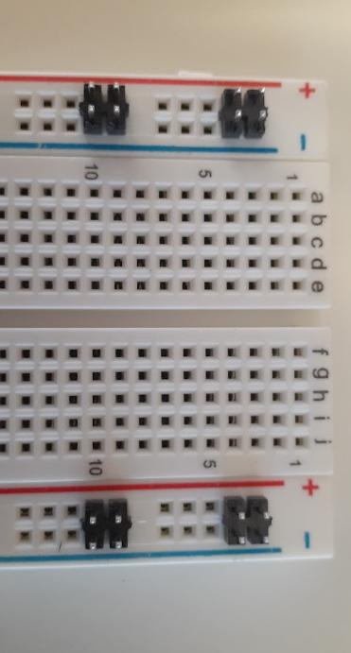 Snap off the header pins in 2x2 groups. The easiest way to do this is to use two needle nose plyers. On the breadboard there five pin groups going down the power rails. Orientate the header pins as seen in the picture in the first slots of two adjoining five pin groups. Notice the snap off tabs are all orientated in the same direction.

Figure 12-7 Header Pin Alignment to breadboard

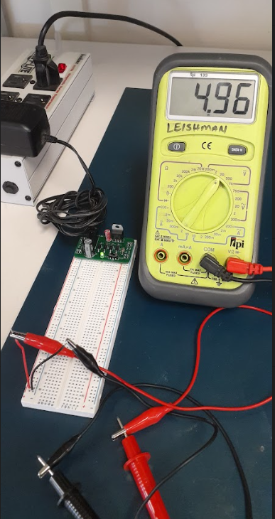 Place the PCB on the header pins and press firmly and make sure all the header pins are square and flush to the breadboard. Solder the header pins in place, from the top of the PCB.

Figure 12-8 Place PCB on header pins.

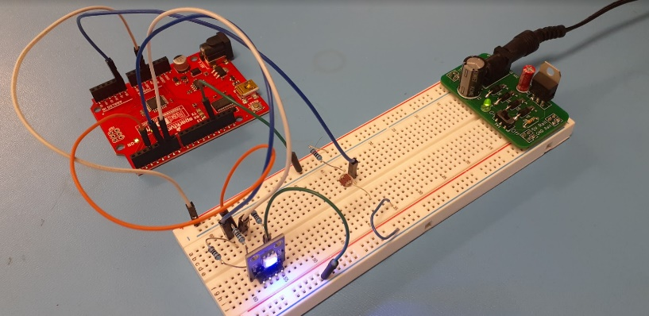 After soldering the header pins, the Breadboard Power Supply is complete. Plug in your ACDC wall adapter. Test that the green led turns on and off with SW1 and verify that both power rails have 5VDC.

Figure 12-10 Breadboard Power Supply powering an Arduino project.

Figure 12-9 Final Test

**Conclusion**

<https://www.osha.gov/sites/default/files/2019-04/Basic_Electricity_Materials.pdf>

<https://media.digikey.com/pdf/Data%20Sheets/ST%20Microelectronics%20PDFS/2N3904.pdf>

<https://www.onsemi.com/pdf/datasheet/1n5221b-d.pdf>

<https://i.stack.imgur.com/zsp7C.png>

<https://www.st.com/content/ccc/resource/technical/document/datasheet/41/4f/b3/b0/12/d4/47/88/CD00000444.pdf/files/CD00000444.pdf/jcr:content/translations/en.CD00000444.pdf>

<https://www.onsemi.com/pdf/datasheet/1n4001-d.pdf>

<https://media.digikey.com/pdf/Data%20Sheets/ON%20Semiconductor%20PDFs/TIP41A-D.pdf>

<https://www.diodes.com/assets/Datasheets/AS78XXA.pdf>

<https://portablepowerguides.com/how-many-amps-is-a-9-volt-battery/>

<https://www.we-online.com/katalog/datasheet/151031VS06000.pdf>